**How to View All Progress Monitoring Data points**

Go to the main page

Click on the exact box (score) of the

Student in the probe you would like to view

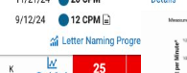Then press _____ probe name progress

(For example: letter naming progress)

(the graph)

You will see a graph like this and all of their scores are below.

To see the exact assessment and what letters they know/ and did not know press

View

